Pinball Design OnShape Instructions

1. Make a copy of the pinball starter template in Onshape.
   1. From your Onshape home page, click on the “Public” item in the left-side menu.

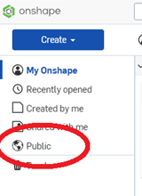

* 1. In the search box at the top, type (in quotes) “Eckerd Pinball Starter” and hit the enter key.



* 1. The template should appear in the results list. Hovering over the template, click-right and choose “Copy workspace…” from the pop-up menu.

1. The starter template contains three sketches, named “Playfield”, “Wood Extrusions”, and “Panels”. You can think of these sketches as forming a three-layer cake that is the playing surface of the pinball machine.
   1. The Playfield sketch is the bottom layer of the cake. It contains all the holes (circular or otherwise) that will be cut through the playfield on the CNC router. This sketch should contain all the game mechanisms and all the screws, posts, etc. that will attach items to the playfield. The lower portion of the playfield is already populated with flippers, slingshots, and lane guides. You should not change the overall shape of the playfield or the lower playfield design without approval from your instructor.
   2. The Wood Extrusions sketch is the middle layer of the cake. It contains wooden parts that will be attached to the playfield. The ball guides in the lower part of the playfield are already present in this sketch. You will need to extend these guides into the upper part of the playfield as appropriate for your design. Add any islands called for by your design.
   3. The Panels sketch is the top layer of the cake. Panels are used to cover/protect mechanisms, wood islands, etc. They also provide a surface for decoration. The Panels layer already contains cutouts to cover the slingshots in the lower playfield.
2. Make a copy of the “Eckerd Pinball Parts” document, in a manner similar to that used in Step 1. This document contains sketches for the cutting templates of various pinball mechanisms in your build kit.
3. You create your playfield design by pasting the templates of pinball mechanism into the Playfield sketch. **You should not create an assembly for the playfield.** The playfield is a single part – one piece of wood that has a lot of holes in it! ***[Note for the future: doing things this way is a pain, as the constraints on some parts sketches make it hard to place them the way you want to. It might be easier to create an assembly and then generate a DXF diagram that can be used for CNC cutting of the playfield. I don't know enough about generating diagrams at the moment to make the call.]***

The most convenient way to create your design is to open the Eckerd Pinball Starter and the Eckerd Pinball Parts documents in different browser tabs. To place a cutting template into the Playfield sketch of your machine design:

* 1. Open the template of the mechanism.
  2. Right-click on the name of the sketch in the Features list and choose “Copy Sketch” from the pop-up menu.

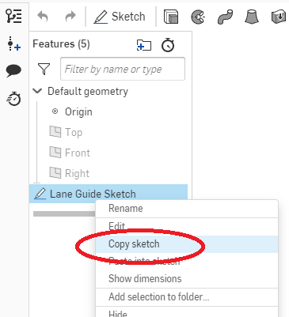

* 1. Click-right in the Playfield sketch and select “Paste Sketch Entities”.

**Important note about pop bumpers:** Do not reflect the pop bumper sketch! The holes for the bumper base only fit with the bumper body in a particular orientation, which gets messed up when you reflect the sketch.

1. Add other playfield elements (cutouts, posts, etc.), wood extrusions, and panels as appropriate. The diameters of some common elements are:

|  |  |  |
| --- | --- | --- |
| *Element* | *Thru-hole Diameter* | *Element Diameter* |
| Finned Star Post 1-3/16" | 0.12” | 0.7” (includes rubber bumper) |
| Narrow Plastic Post 1-1/16" Tall | 0.12” | 0.7” (includes rubber bumper) |
| #8 wood screw | 0.17” | 0.17” |
| #6 machine screw | 0.12” | 0.12” |
| Leaf Switch | none | 0.625” |

**Important note about posts and elastic bands:** Posts can only accommodate a single elastic band, which rests in a notch around the post. Each elastic band requires at least two posts. If you wish to have a chain of elastic bands, you cannot share a post between the bands. Think about it: the elastic bands must all be at the height of the pinball's radius (i.e., it's middle) and if you are sharing a post, one of the bands is going to be too high or too low.

1. Be sure to leave enough clearance between parts to allow the pinball to travel freely. The pinball diameter is 1.0625 inches. The easiest way to test for proper clearance is to add a circle with a diameter slightly larger than a pinball (say, 1.08 inches) and drag it around your playfield and ensuring it can pass between parts without touching them.
2. If you want to construct a lane containing a rollover switch, the lane should be 1.3 inches wide. If you make the lane much wider, the ball might not roll over the switch (and could even get stuck between the switch and the lane wall).
3. Review the final design with your instructor.
4. After completing your design, export each sketch in the design as a DXF file.
   1. Right-click on the sketch in the Features list and select “Export as DXF/DWG”.
   2. In the dialog that appears, set the Format to “DXF”, Version to “2018”, and Options to “Download”. Send the Playfield and Wood Extrusion sketch files to your instructor for cutting on the XCarve.
   3. You are responsible for cutting out the Panels items on the laser cutter.

On-Shape Design for Pinball Stand

The design for the stand we use can be found by searching for the On-Shape document named "Eckerd Pinball Stand".